INTRODUCTION:
This failure would include utility failures such as a sewer or backup sewer affecting patient care or isolating an area and a direct loss of water (domestic) from local providers or an event of too much water such as flooding from coastal levees, dams,s or area waterways or break in water lines causing internal flooding.

A. MITIGATION:

- Potable water can be obtained <<local fire department>> who will respond with an engine and hoses connection through fire department connections, to restore water to the house pumps, and to service the building.
- The <<local water department>> can provide water from several wells including a well near <<Facility Name>> that is powered by emergency generator.
- Pallets of potable water are stored in <<Identify location>>
- Additional mops and wet vacuums are stored in <<Identify location>>
- Pallets of Oil-Dri, buckets, scoops, and trash bags are stored in <<Identify location>>
- Negotiate a contract for potable water supply (bottled) water and potable toilets, if necessary

B. PREPAREDNESS:

- Primary domestic water is supplied through <<number of>> water mains and are located: <<Identify locations and access points>>
- Vendors and Contractors have been predetermined for response to water/sewer events. The information is located in the HICS 258 Hospital Resource Directory
- Development and training of Emergency Response Plan

C. RESPONSE FOR SEWER AND WATER FAILURE:

- When staff discovers a failure in one of these systems, they are to contact the <<Engineering department>> or the Switchboard Operator to inform them of the loss.

- <<Engineering department>> will assess the extent of the failure and notify the affected department of the estimated time the water/sewer will be down. If the water loss is from an outside source, <<local water department>> will be notified at <<phone number>> for immediate assistance.

- Nursing personnel would observe the following restrictions to limit the use of water in caring for patients.

- Disinfectant wet wipes and alcohol-based hand gels should be used as a substitute for hand washing needs. Notify <<Material Management Department>> for additional materials, if needed.
- Limit flushing commodes to disposal of feces or vomitus.
- Substitute juices, with physician's approval, for forced fluids.
- Limit changes of bed linen to those patients who have gross soiling from draining wounds, catheters, etc.
- Dry shampoo and cleaners can be used for cleaning patients.

- The bathroom facilities can be utilized by bagging the toilets for usage (See Attachment I). <<Engineering and Environmental Services>> will place buckets containing ‘Oil Dri’, a scoop, and clear bags in key locations to use for bagging toilets. Once the trashcan is full, the bags with waste will be disposed of in soiled utility rooms by the staff within that area. Environmental services will round the soiled utility rooms for the removal of the trash.

- In the event of an extended water failure, <<EVS>> staff will post “Out of Order” signs on public and employee restroom doors that have been closed.

- If available, portable toilets will be used by employees and visitors. Signage will be placed in the hallways as to the location of the portable toilets.

- Drinking water will be made available through the use of bottled water obtained by contacting <<Dietary Services department>>. Backup meal plans will be determined during the event.

- Surgery, Cath Lab, and Endoscopy/GI areas will determine caseloads

- <<Engineering>> will determine if an audible house fire alarm needs to be disabled to prevent a false flow switch alarm, due to loss of water.

- Suspend all disinfecting and sterile processing procedures. Account for packs and decontaminate with potable water or place contaminated instruments into biohazard bags until water returns.

- Dialysis will be shut down and patients rescheduled or transferred when reserved water is low. If the water is lost during the procedure, follow the protocol to hand pump the machines and return the patient’s blood.

D. RESPONSE TO FLOODING:

- Determine and isolate water lines or the cause of flooding. Conduct a risk assessment to determine hazards and response.

- Remove all individuals and equipment within the area of flooding. If hazards exist, any exposures to staff, patients,s or visitors will be medically evaluated.

- Staff will be assembled to begin cleaning up the area affected. Equipment, such as fans, floor/carpet extractors, wet vacuums, mops, and towels, will be potentially used. PPE will be utilized while cleanup occurs.

- Call vendor/contractor for response to flooding.

- <<Engineering>> will determine if an audible house fire alarm needs to be disabled to prevent a false flow switch alarm, the f sprinkler head has been disabled. Perform ILSM Assessment and Measures.

- Begin drying the walls and floors. After 24 hours, determine the wicking of walls with a moisture meter. If determined, that walls or floors need to be removed and replaced, a construction project will be opened for the area.

E. RECOVERY:

- Replenish any stores of water, oil dry, or other stock used during the emergency. Clean equipment used during the event.

- Once the water has been restored, the following must be done:
  - Check the domestic water lines for shocks that have been blown.
  - Check the function of all RO and filtration systems. Change filters and cartridges in systems.
  - Flush toilets, sinks, water fountains, coffee makers, ice machines, and Y-strainers and test systems for proper working order.
  - Manual reset on water heaters.

- Continue construction or renovation of areas damaged from excessive water or loss of water.

- Bottled water will be continued for a minimum of 24 hours. Before the restriction is lifted, <<Safety Officer>> will conduct testing of water quality. Upon approval and after testing indicates safe to drink, will announce a lift of water restrictions.

ATTACHMENT I- TOILET USAGE DURING WATER FAILURE

- Place the large clear trash bag over the toilet and close the toilet seat over the bag.
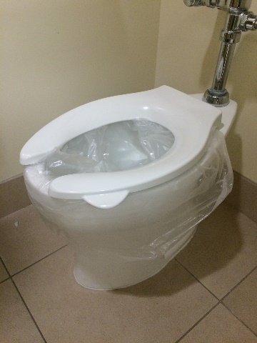

- The toilet is ready for use.

- After usage, use the scoop and ‘Oil Dri’ provided in a bucket of the restroom. The amount of ‘Oil Dri’ to waste is 1:1.
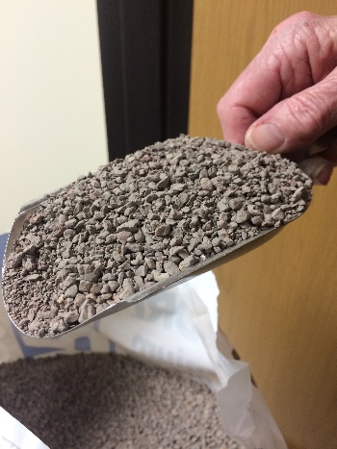
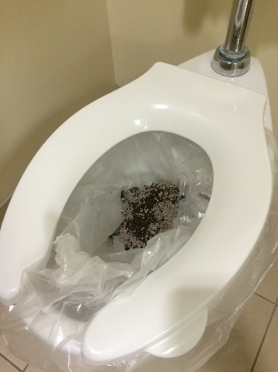

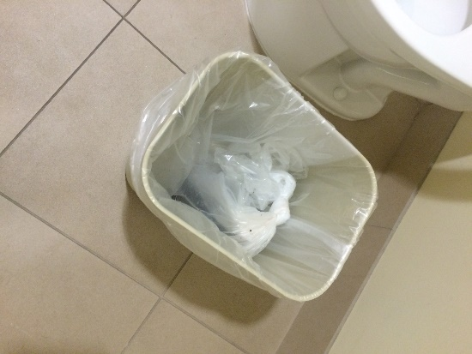
- Raise the toilet seat and tie the clear bag closed. Remove the bag and place it in the trashcan provided in the restroom.
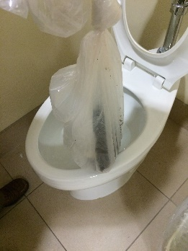
Ill

